Screenshot 1

Screenshot 2

Screenshot 3

Screenshot 4

Screenshot 5

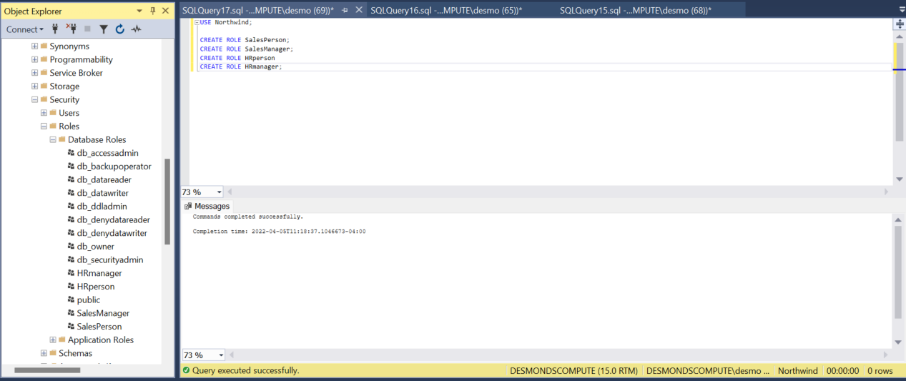

Screenshot 6

Screenshot 6a

Screenshot 7

Screenshot 8

Screenshot 9

Screenshot 10

Screenshot 11

Screenshot 12